# Manipulating the Current Date and Time - Final Version

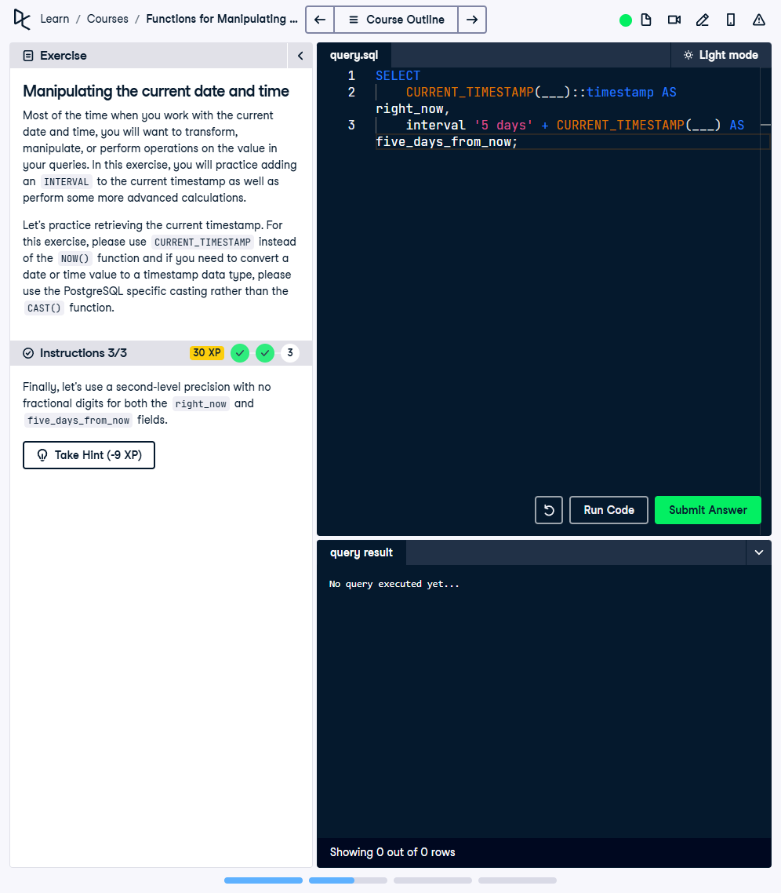

Question:

1. Select the current timestamp without timezone and alias it as 'right_now'.  
2. Select a timestamp five days from now and alias it as 'five_days_from_now'.  
3. Use second-level precision with no fractional digits for both 'right_now' and 'five_days_from_now'.

## Answer:

-- Final query with second-level precision and aliases  
SELECT  
 CURRENT_TIMESTAMP(0)::timestamp AS right_now,  
 CURRENT_TIMESTAMP(0)::timestamp + INTERVAL '5 days' AS five_days_from_now;

## Explanation:

1. CURRENT_TIMESTAMP(0): Retrieves the current timestamp with second-level precision, removing fractional seconds.  
2. ::timestamp: Casts the current timestamp to a type without timezone.  
3. CURRENT_TIMESTAMP(0)::timestamp + INTERVAL '5 days': Adds 5 days to the current timestamp, keeping the second-level precision.  
4. AS right_now / AS five_days_from_now: Assigns aliases to the results for better readability.